Developer’s report

*Task: Implementation*

**Name: Le Xuan Hoan**

1. Refactor HMS model
   * I refactored our model again because all classes of **puf.m2.hms.model** (**Patient**, **Physician** …) have very alike properties and methods (id, getNextFreeId(), save(), update()), which I believe would be extracted to a common place
   * The new class diagram as follows:

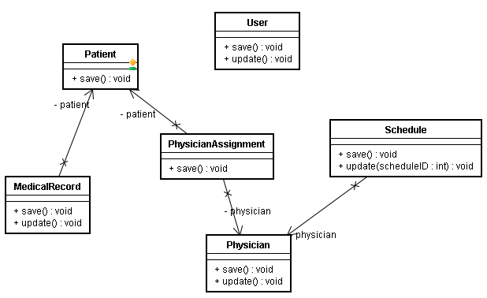

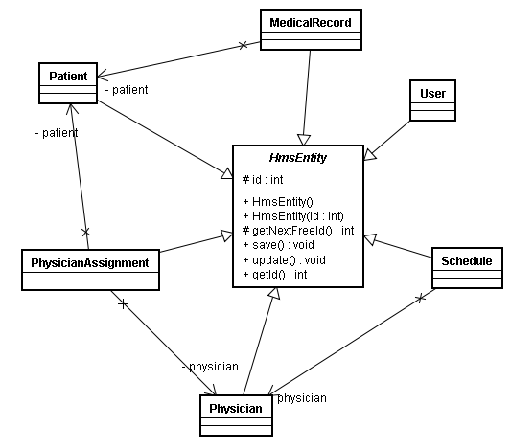

* HmsEntity uses Reflection API to look for properties annotated by DbProp, and composes the corresponding sql query for saving/updating

1. Update maven POM to support packaging the program
   * To prepare for release, now it would be a suitable time for us to have the program packaged. I modified maven POM of our project to use maven-assembly-plugin. Now to package the program, we only need to invoke:

**mvn package**

1. Refactor unit test of HMS model
   * Together with the maturity of the model, I’m gradually removing using mock objects for unit test, change to use real objects
2. Support tasks
   * Once again, working collaboratively with the remaining programmer, I helped him to solve some problems:
     1. Update the model as necessary (add necessary methods)
     2. Solving github problem (some laptops cannot access github through ssh, so my solution is change to use https)
     3. Solving EasyMock issue (found out a way to simulate throwing exception from void methods)
3. Next iteration
   * For next iteration, the followings will be taken into account:
     1. As discussed before, next iteration will be the last one, I will take the role of manager. Important things will be probably preparing for the release of the program
     2. Still work as a programmer or help other programmers finish their tasks